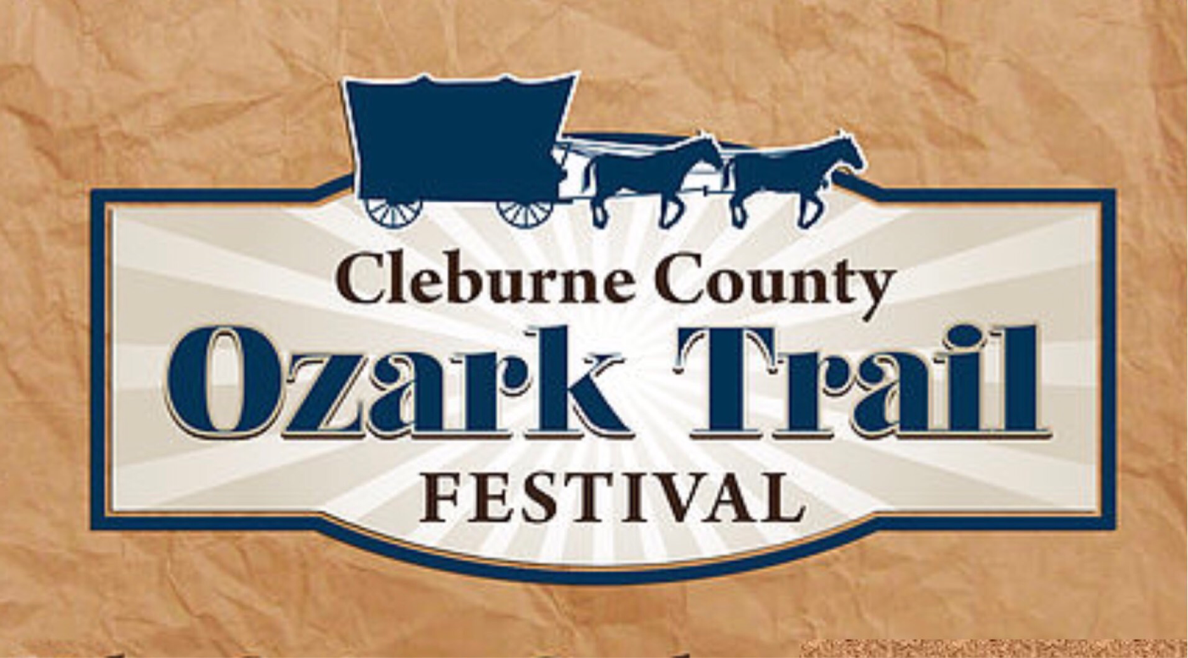
Ozark Trail Fest 2021 Vendor Application
Friday October 8th: 9:00am-Dark Saturday October 9th: 9:00am-8:00pm
Optional Setup: Thursday October 7; Noon till Dark
Vendor Name: ___________________________________________________________
Business Name: __________________________________________________________
Address: ________________________________________________________________
Phone: _________________________________________________________________
Email: _________________________________________________________________
Website: ________________________________________________________________
Description of items to be sold: ______________________________________________
Are you a returning Ozark Trail Fest Vendor? _____Yes ____No
Arts & Crafts vendor must submit 2-3 photos

A signed application constitutes a contract to follow and be bound by Rotary Club of Cleburne County rules and regulations and is a commitment to participate if accepted. Violations of rules and regulations prior to, during or at the end of the show will result in loss of exhibitor space without refund. Applicant certifies that photos submitted accurately depict applicant’s materials. Applicant certifies that photos submitted are the product of the applicant. Applicant will not be considered if: this form is incomplete, unsigned or received without correct fee and pictures. By signing this application, vendor agrees that if accepted this application represents the entire agreement between parties with respect to the subject matter, terms and conditions herein. I have read the above regulations for the Ozark Trail Fest, and I agree to abide by all of them with no exceptions, and do hereby contract space, if accepted for the 2021 festival. All Fees are non-refundable.
The Rotary Club of Cleburne County holds fundraisers to raise money for projects, scholarships and grants given to agencies that qualify, in an effort to strengthen our community.

Booth Fees: Arts & Crafts $65_________ Pavillion$75______
Electricity $15__________ x Number of booths__________
Total Amount Enclosed_______________
Payment must be received with your application by September 18, 2021.

Mail to: Rotary Club of Cleburne County 103 S. 3rd Street, Heber Springs, AR 72543
Email: ozarktrailfest@yahoo.com Phone: (501)206-9866
Make checks payable to: Rotary Club of Cleburne County with OTF in the memo line

Rules and Regulations

1. Exhibitors must furnish their own tent, table, chairs, extension cords, lighting, etc.
2​. All displays should be designed and constructed in good taste.
3. Booth spaces are 10 foot by 12 foot with minimal footage available for storage. If an exhibitor needs more than 12 feet of space, two booth spaces must be purchased.
4. Exhibitors must bring enough stock for the entire show.
5. Exhibitors may only display and sell products within the category for which they were accepted.
Any items of work which are not listed on the application will be deemed non-acceptable and removed from
the show. Please list every item to be sold. Items cannot be added after acceptance.
6. The OTF committee reserves the right to remove products, works or displays considered objectionable to the public or inappropriate for a family event and may do so without refund to the exhibitor.
7. Exhibitors must check-in between 8:00 a.m. and 11:00 a.m. on Friday, October 8. If setting up on Thursday, please let us know in advance
8. Exhibitors are responsible for collecting, reporting and paying all sales tax collected to the appropriate revenue division. Forms and information will be provided in the check-in packet.
9.Vehicles and storage trailers are not allowed to be used as a booth or in your booth.
10. All crafter/vendor vehicles and trailers must be moved to the vendor parking area from Friday noon through Saturday at 7:00 p.m. Violators will be subject to having the vehicle towed at crafter/vendor expense.
11. No refunds will be given due to inclement weather. Rain or shine, the festival will go on as planned. Exhibitors are required to be present for the entire festival. If a decision is made regarding the festival based on weather, exhibitors will be notified accordingly in a timely manner.
12. Nominal security will be provided after hours. OFT will not be responsible in any way for loss or damage to a participant’s property. Each exhibitor will be responsible for securing their booth each night.
13. Exhibitors are responsible for keeping the assigned area clean and orderly.
14. Active solicitation outside assigned booth is prohibited.
15. The festival officially closes at 8:00 p.m. on Saturday, October 9, 2021.

I have read the above regulations for the Ozark Trail Festival 2021, and I agree to abide by all of them with no exceptions, and will not hold Cleburne County, Ozark Trail Festival Committee, Rotary Club of Cleburne County or anyone associated with the festival responsible for loss or damage to property or for accidents. I hereby contract space, if accepted, for the 2021 festival.

Date:_____________________ Vendor Signature_________________________

